STUDENT BRAIN

An Intelligent Academic Command Center & Study Network for University Scholars

Course Title : Software Engineering Laboratory
Course Code : CSE 3422
Department : Department of Computer Science and Engineering
Institution : United International University
Team Name : Team Zero One
Project Repository : https://github.com/souravsahapartho/uiu-student-brain.git

INDEX
Click any section title to jump to that part of the document
Project Team Members: 1
Mapped Program Outcomes (PO) 1
Abstract 1
1. Introduction & Background 1
2. Problem Statement &Motivation 1
3. System Objectives 1
4. System Architecture Overview 1
5. Comprehensive Feature Walkthrough 1
5.1 Welcome & Landing Interface 1
5.2 High-Speed Authentication & Onboarding Pipeline 1
5.3 Academic Profile & Goal Configuration 1
5.4 Scholar Command Center Dashboard 1
5.5 Study Planner 1
5.6 Scheduled Study Tracker & Live Focus Session 1
5.7 Post-Session Gemini AI Diagnostic Testing 1
5.8 Interactive Solution Breakdown & Concept Explanations 1
5.9 Study Materials Hub & Native Document Reader 1
5.10 Course-Specific AI Chat Assistant 1
5.11 Grade Planner & GPA Trajectory Forecasting 1
5.12 Cross-Module Academic Analytics Dashboard 1
5.13 Scholar Social Network & Community Hub 1
5.14 Privacy-Preserving Global Study Leaderboard 1
5.16 Native Android Mobile Application 1
6. Technology Stack & Implementation Details 1
7. Core Mathematical Formulations & Algorithmic Logic 20
7.1 Grade Planner & GPA Trajectory Forecasting Mathematics 20
7.2 Calendar Study Planner & Routine Collision Algorithms 22
7. System Testing & Validation 1
8. Technical Challenges Encountered 1
9. Future Enhancements 1
10. Conclusion 1

Project Team Members:
- Rafayet Hossen (Lead Backend & AI Architect)
  - Core Responsibilities: Architecture of scalable Django REST APIs, implementation of Google Gemini AI pipelines for document processing, high-throughput JWT authentication, and DevOps orchestration.

- Sourav Saha (Mobile & Community Lead)
  - Core Responsibilities: Engineering the native Flutter Android application, integrating the hardware Text-to-Speech (TTS) Voice Coach, and developing the real-time Scholar Social Network infrastructure.

- Baitun Nahar Bithy (UI/UX Lead & GPA Specialist)
  - Core Responsibilities: Designing immersive onboarding experience, optimizing cross-platform user interfaces, and formulating the mathematical models for the Weighted GPA Forecasting Engine.

- Saptarshi Biswas Supty (Frontend & Planner Specialist)
  - Core Responsibilities: Building the React 19 Single Page Application (SPA), engineering the autocomplete routine time-blocker, and architecting the interactive Study Materials Hub.

Mapped Program Outcomes (PO)
- PO2: Problem Analysis
  - Alignment & Engineering Justification: Conducted a rigorous analysis of academic retention bottlenecks, prerequisite scheduling conflicts, unmonitored study patterns, and delayed GPA awareness to formulate a comprehensive computational solution.
- PO3: Design and Development
  - Alignment & Engineering Justification: Architected a Clean Architecture system featuring strict Service-Layer decoupling between the Django backend and React/Flutter clients, an automated 12-trimester prerequisite validation engine, and multimodal AI-driven assessment workflows.
- PO5: Modern Tool Usage
  - Alignment & Engineering Justification: Leveraged a modern technology stack including React 19, Vite, Tailwind CSS, Flutter 3.47, Django 6.0, PostgreSQL 16, Google Gemini 2.0 Flash AI, Docker, and Nginx reverse proxy.
- PO8: Ethics&Privacy
  - Alignment & Engineering Justification: Ensured stringent data privacy protocols via encrypted local storage, implemented strict opt-in mechanisms for the global leaderboard, and utilized AI solely for self-assessment to uphold academic integrity.
- PO9: Teamwork
  - Alignment & Engineering Justification: Successfully distributed complex modular components (Backend Services, Frontend SPA, Mobile Client, and Database Schema) across a four-member team, maintaining transparent and measurable accountability.
- PO10: Communication
  - Alignment & Engineering Justification: Developed and maintained meticulous technical documentation, architectural schematics, REST API payload schemas, and formal academic reporting.

- PO12: Lifelong Learning
  - Alignment & Engineering Justification: Demonstrated continuous learning by acquiring proficiency in advanced paradigms outside the standard academic syllabus, including AI prompt chaining, native OS integrations, and reactive Riverpod state management.

Abstract
Higher education scholars frequently encounter severe academic friction driven by fragmented administrative tools, disorganized study materials, prerequisite oversights during trimester registration, and passive learning methodologies. Student Brain proposes a unified, cross-platform academic operating system and collaborative study network explicitly calibrated for the UIU BSCSE curriculum. The platform seamlessly integrates an intelligent 12-trimester course autocomplete routine planner, time-gated focus tracking augmented by a native hardware Text-to-Speech (TTS) voice coach, and automated diagnostic assessments powered by Google Gemini 2.0 Flash AI. Furthermore, it incorporates quality-point GPA trajectory forecasting and a privacy-preserving global study leaderboard, culminating in a holistic digital mentor that optimizes scholastic efficiency and peer engagement.

1. Introduction & Background
Success in tertiary education necessitates rigorous time management, active cognitive recall, and strategic navigation of degree requirements. Contemporary university workflows predominantly rely on dispersed paper-based notes and unmonitored study routines, which often lead to suboptimal academic outcomes. Student Brain introduces an intelligent, centralized digital ecosystem that bridges desktop web and mobile Android environments. By consolidating disparate academic tasks into a singular command center, the system empowers students to maximize their daily scholastic potential and proactively manage their academic trajectories.

2. Problem Statement & Motivation
- Advisement & Prerequisite Ambiguity: Students frequently encounter scheduling conflicts or mistakenly enroll in courses without satisfying mandatory prerequisites, leading to administrative complications.
- Passive Learning Paradigms: A prevalent reliance on passive reading without structured time-blocking or active self-testing significantly diminishes long-term knowledge retention.
- Deficit of Immediate Diagnostic Feedback: The absence of rapid conceptual verification following independent study sessions leaves foundational knowledge gaps unaddressed until formal examinations.
- Delayed GPA Feasibility Awareness: Manual calculation of required credit grades for specific graduation honors is inherently error-prone and often realized too late in the degree lifecycle.
- Scholastic Isolation: There is a distinct lack of a dedicated, distraction-free social network tailored exclusively for academic peer motivation and collaborative study tracking.

3. System Objectives
- Engineer a high-performance, cross-platform architecture comprising a React 19 Web SPA and a Flutter Android Application, synchronized via a highly available Django-based cloud backend.
- Formulate an autocomplete curriculum matrix encompassing all 12 trimesters of the UIU BSCSE program, featuring automated prerequisite validation and exam-slot collision prevention algorithms.
- Deploy Google Gemini 2.0 Flash AI to dynamically synthesize diagnostic multiple-choice questions and conceptual explanations directly from user-uploaded study materials.
- Implement sophisticated mathematical models for cumulative CGPA calculation, course retake simulations, and predictive forecasting for remaining degree credits.
- Optimize API latency to provide sub-5ms authentication error responses and deliver embedded, single-roundtrip JWT payloads for accelerated client hydration.

4. System Architecture Overview
Student Brain is built upon Clean Architecture principles, ensuring strict Service-Layer decoupling across all operational tiers to maintain high scalability and maintainability:
- Client Tier: React 19.2 paired with Vite SPA for the Web interface, and Flutter 3.47 utilizing Riverpod 2.6 for the native Android application.
- Gateway & Proxy: Nginx reverse proxy configured for SSL termination, secure routing, and rate limiting.
- Application Server: Python 3.12 utilizing Django 6.0 and Django REST Framework (DRF), deployed via a Gunicorn WSGI HTTP Server.
- Data & Persistence: PostgreSQL 16 relational database engine featuring a normalized schema to guarantee transactional integrity.
- Cognitive Intelligence: Integration of the Google Gemini 2.0 Flash multimodal AI API for advanced document processing, context extraction, and diagnostic quiz synthesis.
- Hardware Integrations: Utilization of Android Native Text-to-Speech (TTS) audio engines and local push notification services for immersive user interaction.

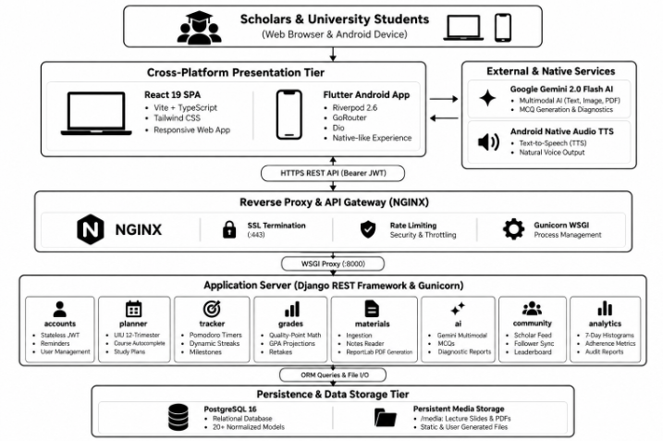
Figure: System Architecture Diagram

5. Comprehensive Feature Walkthrough
5.1 Welcome & Landing Interface
- Features an ambient, glassmorphic UI enriched with glowing gradients and orbital intelligence badges.
- Provides a direct, secure download gateway for the official website.
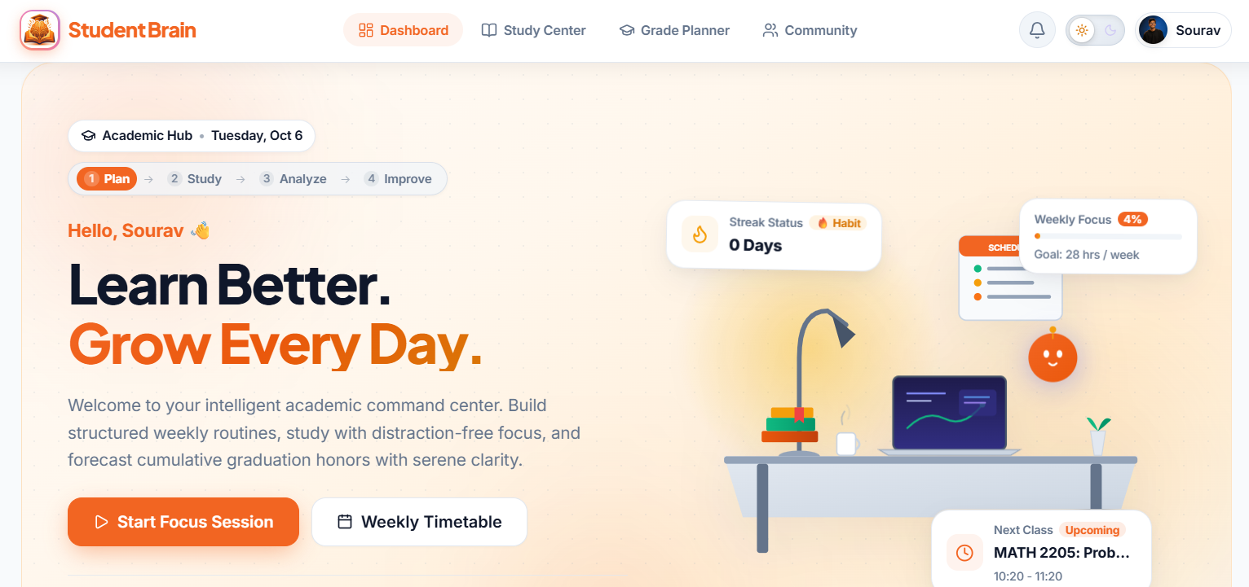
Figure: Home Page
5.2 High-Speed Authentication & Onboarding Pipeline
- Executes sub-5ms indexed email verification, intelligently bypassing redundant PBKDF2 hashing operations upon invalid credential submission.
- Delivers an embedded single-roundtrip login payload that bundles JWT access/refresh tokens with the complete user profile, eliminating secondary fetch requests.
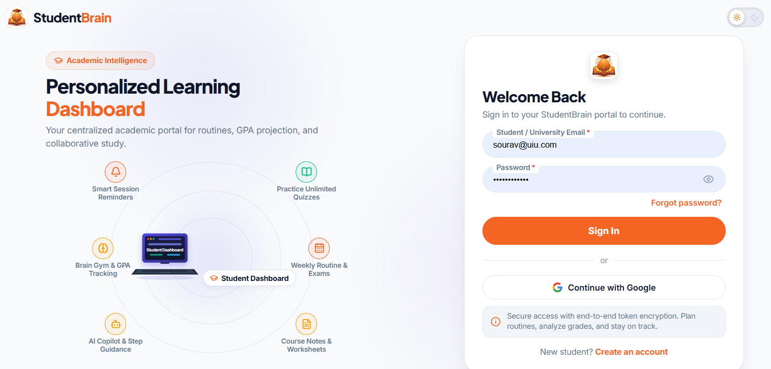
Figure: Authentication Page

5.3 Academic Profile & Goal Configuration
- A visually immersive onboarding modal that precisely captures completed credits, target CGPA objectives, and personalized daily focus hour commitments.
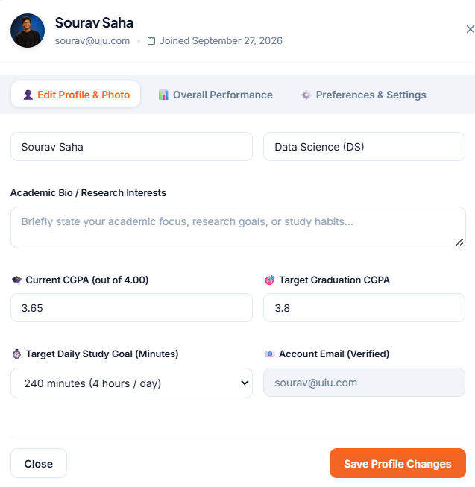
Figure: Profile and Goal Configuration
5.4 Scholar Command Center Dashboard
- A non-blocking, dynamic dashboard rendering real-time study streaks, daily target adherence ratios, and immediate upcoming class schedules via interactive UI cards.
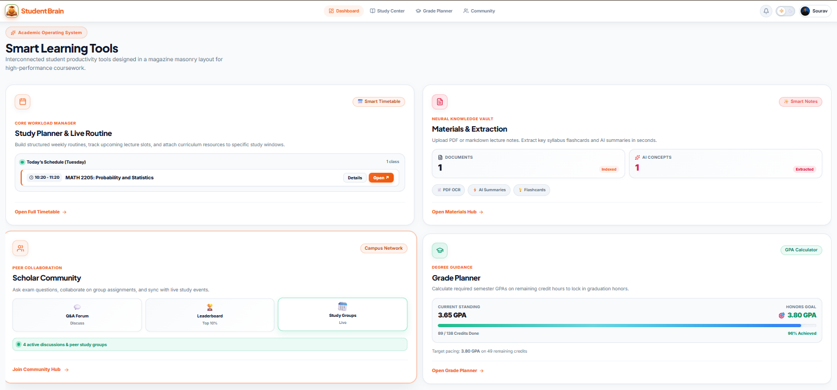
Figure: Scholar Command Center

5.5 Study Planner
- An intelligent, autocomplete directory of all degree courses featuring live credit tracking and proactive prerequisite deficiency alerts.
- A weekly time-blocking calendar grid equipped with spatial room allocation and multi-day routine visualization chips.
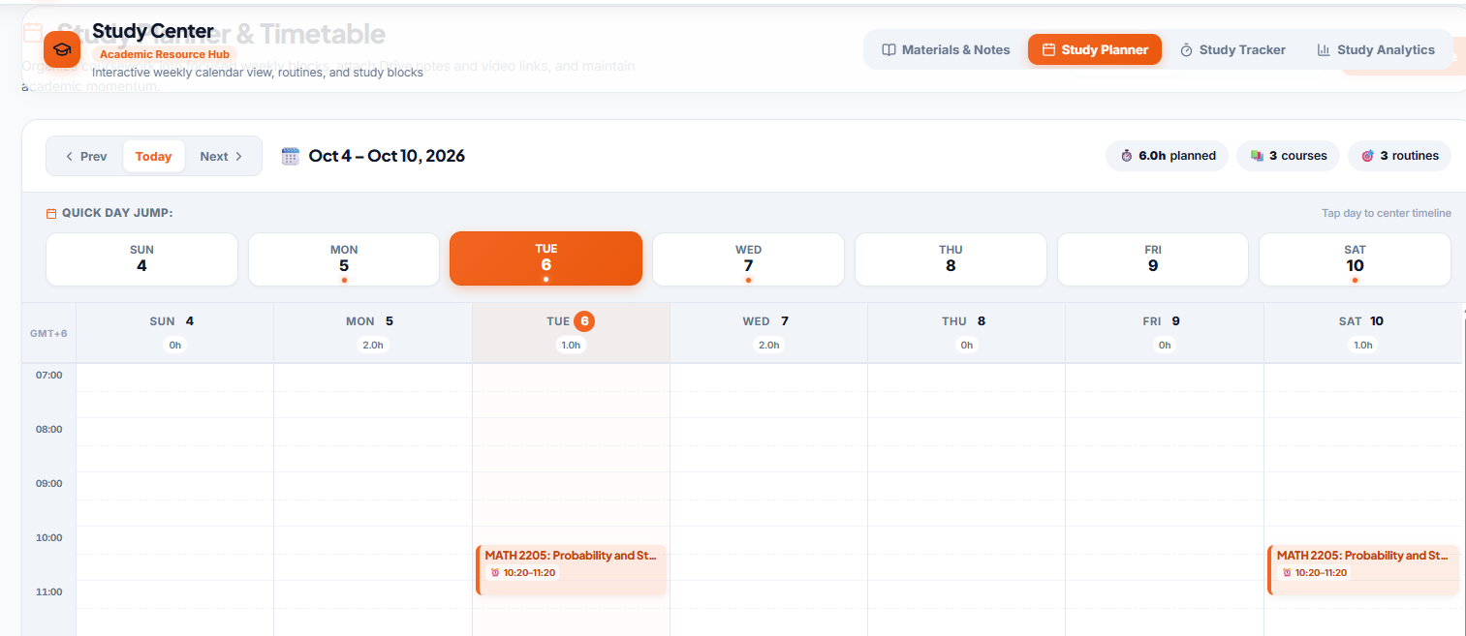
Figure: Weekly Calendar

5.6 Scheduled Study Tracker & Live Focus Session
- Distraction-free Pomodoro and continuous study chronometers, semantically linked to specific enrolled courses and uploaded lecture materials to ensure highly focused sessions.
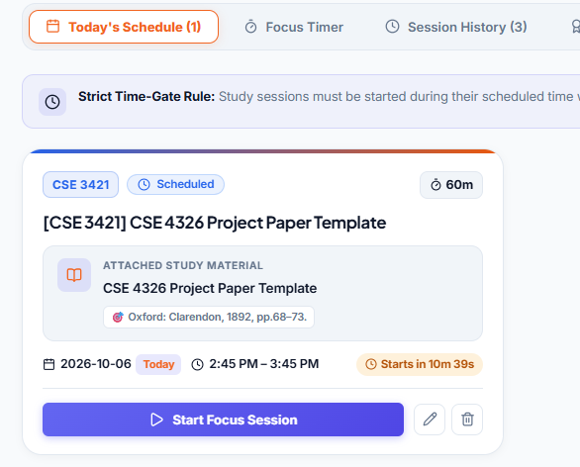 | 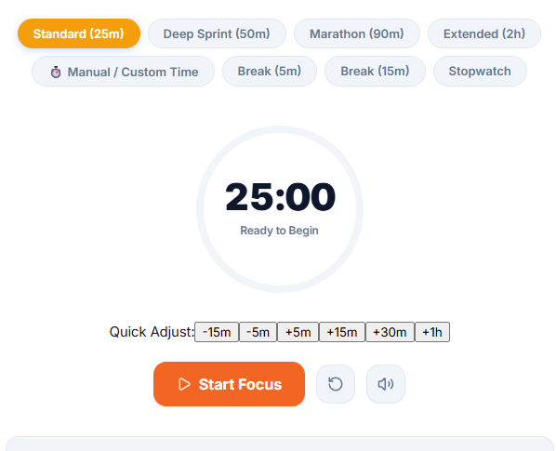
Figure: Study Tracker and Live Focus Session

5.7 Post-Session Gemini AI Diagnostic Testing
- Automated generation of 5-question multiple-choice diagnostic quizzes synthesized on-the-fly by Google Gemini 2.0 Flash extracted directly from user-uploaded notes.
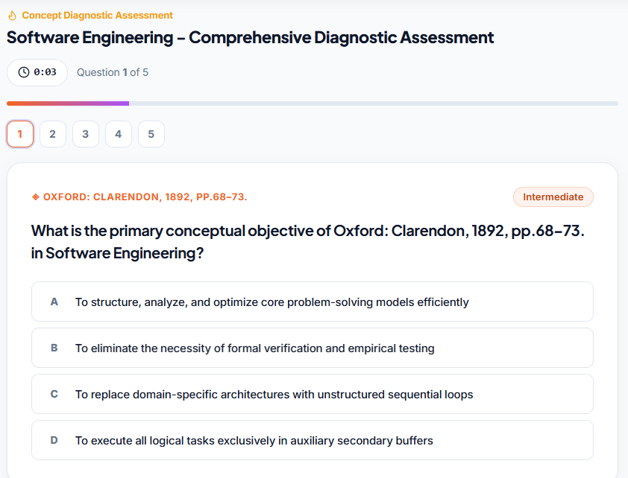
Figure: Post-Session AI Diagnostic Testing

5.8 Interactive Solution Breakdown & Concept Explanations
- An instantaneous scorecard presenting mastery percentages, detailed error analysis, and step-by-step conceptual breakdowns provided by the AI tutor.
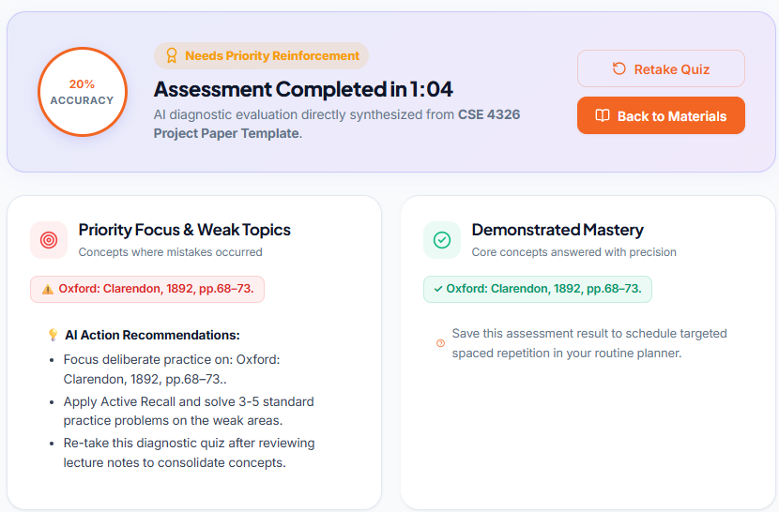 | 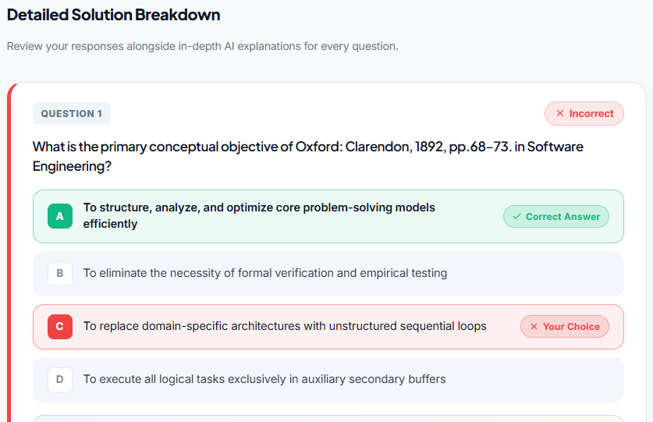
Figure: Solution Breakdown & Concept Explanations

5.9 Study Materials Hub & Native Document Reader
- Robust multi-format document ignition (pdf, .docx, .txt, .md) featuring a distraction-free, in-browser reader and an automated PDF study guide generator.
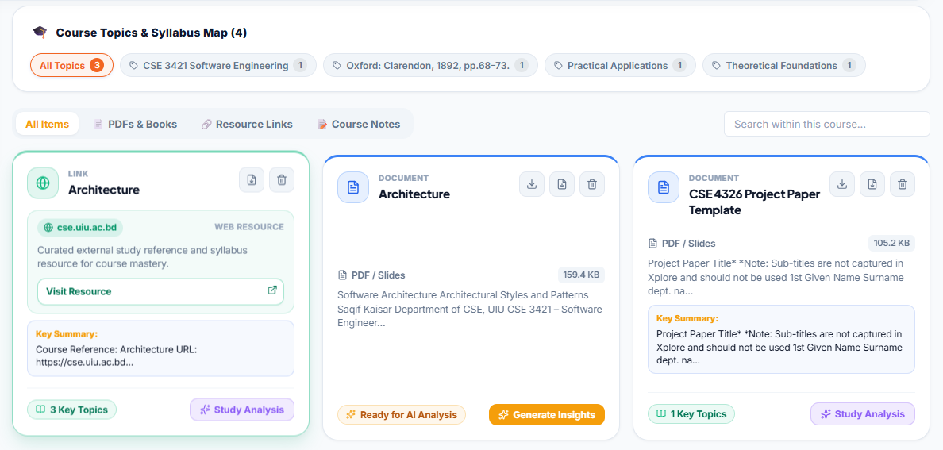
Figure: Study Materials Hub

5.10 Course-Specific AI Chat Assistant
- A highly context-aware AI conversational agent capable of answering complex course-related inquiries, strictly grounded in the context of the uploaded lecture documents.
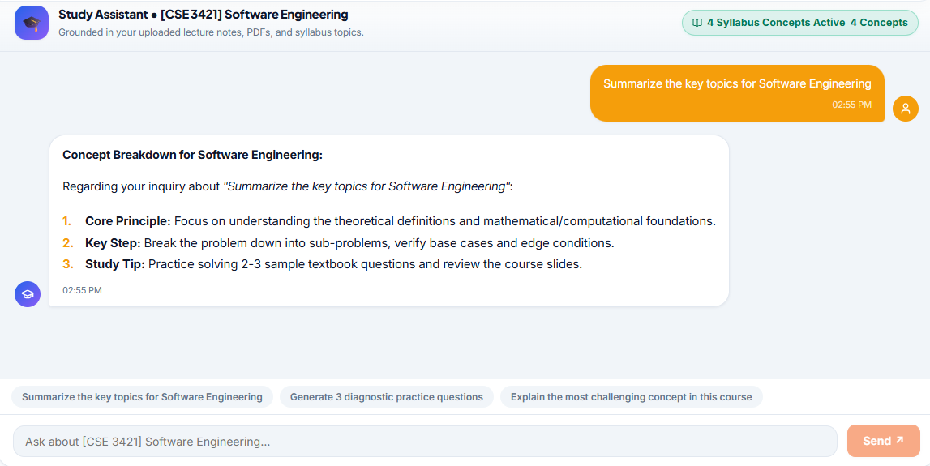
Figure: AI Chat Session

5.11 Grade Planner & GPA Trajectory Forecasting
- A precise mathematical forecasting engine computing the exact required GPA across remaining degree credits necessary to achieve specific honors, visualized via color-coded feasibility badges.
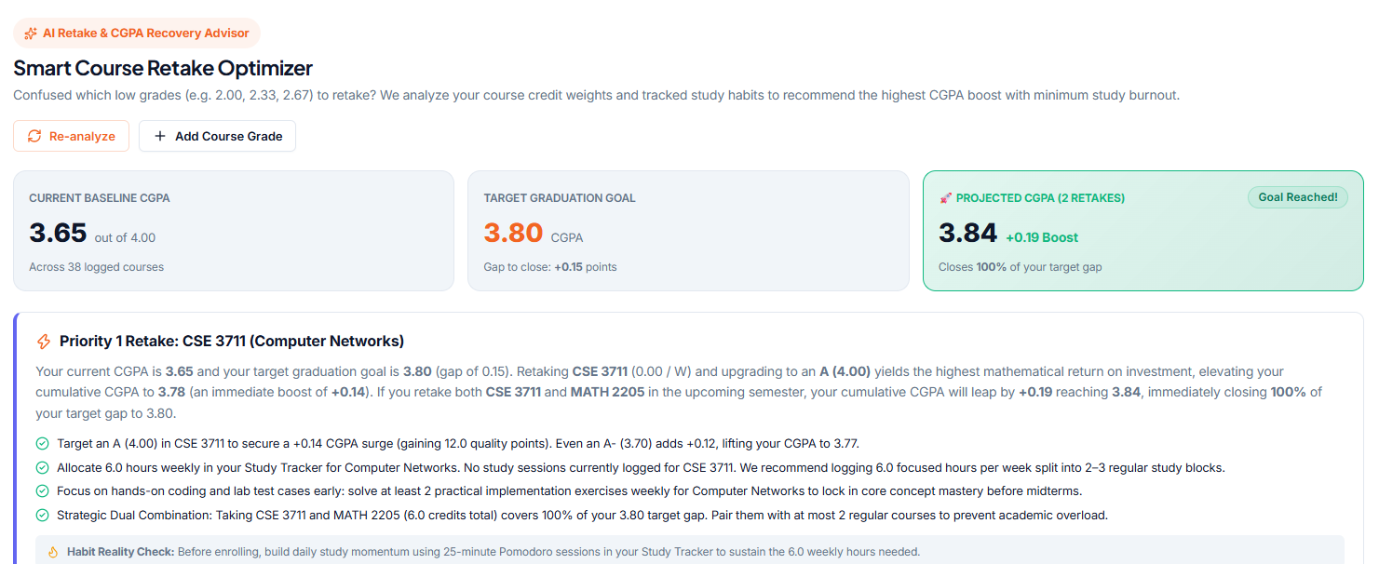
Figure: Grade Trajectory Forecasting

5.12 Cross-Module Academic Analytics Dashboard
- Comprehensive data visualization includes 7-day focus timelines, subject distribution donut charts, and quantitative schedule adherence metrics.
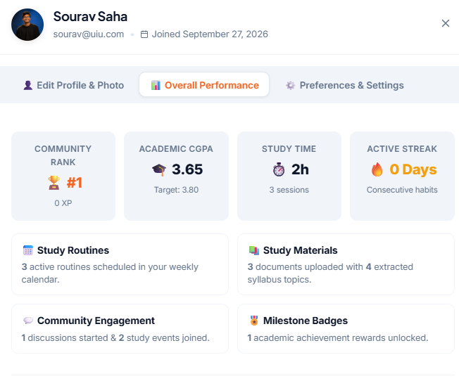
Figure: Analytics

5.13 Scholar Social Network & Community Hub
- A collaborative academic discussion feed supporting rich Markdown formatting, real-time in-place editing, and a robust follower/following synchronization system.
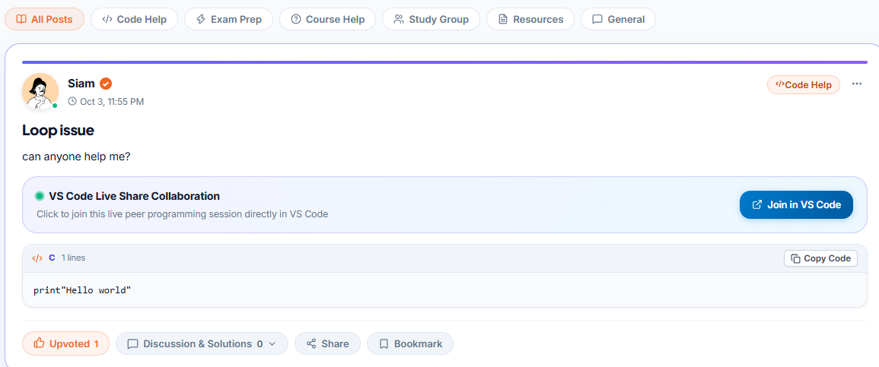
Figure: Community Hub

5.14 Privacy-Preserving Global Study Leaderboard
- A gamified, weekly ranking matrix based on accumulated focus hours and active streaks, ensuring data privacy through strict default opt-in policies and sanitized character rendering.
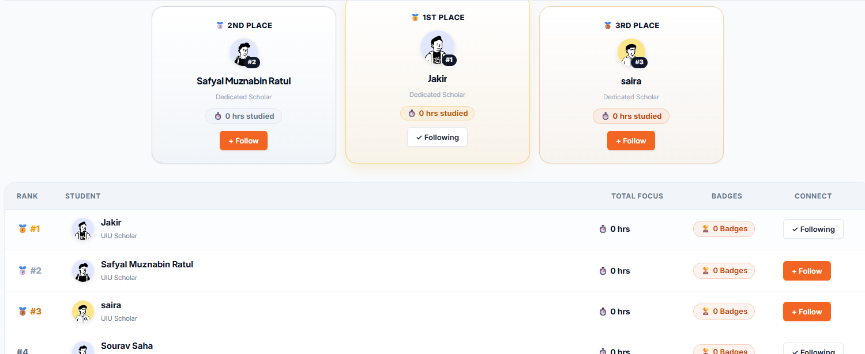
Figure: Global Study Leaderboard

5.16 Native Android Mobile Application
- The official Flutter Android client featuring seamless cloud synchronization, highly optimized fail-safe splash transitions, and an immersive edge-to-edge system UI design.
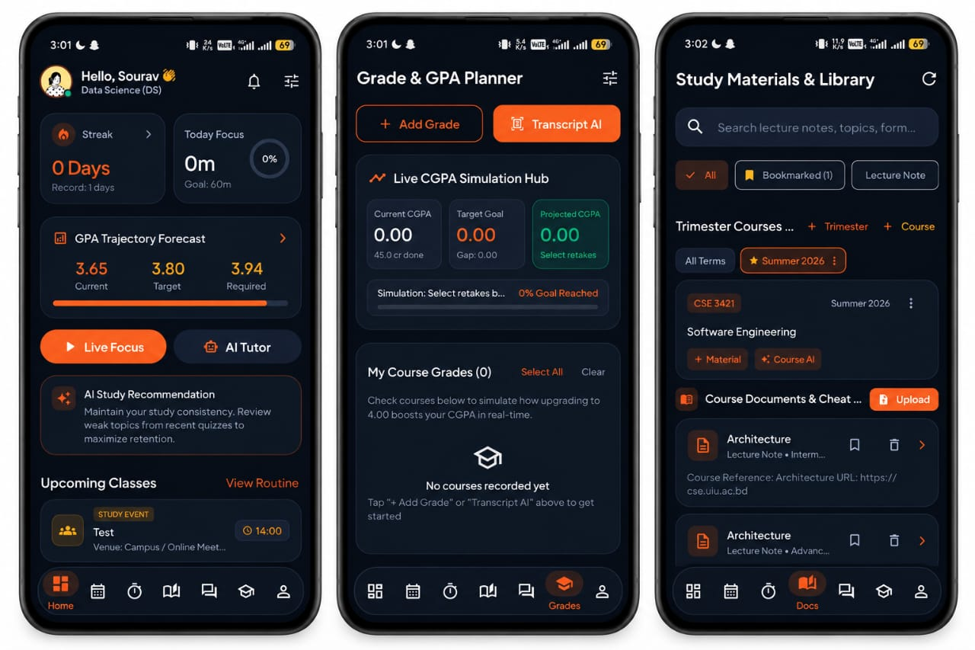
Figure: Native Android Mobile Application

6. Technology Stack & Implementation Details
- Frontend (Web)
  - Technologies Used: React 19.2, TypeScript 5.8, Vite 8.1, Tailwind CSS, Lucide Icons.
  - Key Purpose: Delivery of a highly responsive, component-driven Single Page Application (SPA).
- Mobile (Android)
  - Technologies Used: Flutter 3.47, Dart 3.13, GoRouter, Dio.
  - Key Purpose: Deployment of a cross-platform native mobile application featuring robust offline caching mechanisms.
- Backend API
  - Technologies Used: Python 3.12, Django 6.0, Django REST Framework, PostgreSQL 16.
  - Key Purpose: Provision of a scalable, decoupled REST API gateway structured around the Service-Layer pattern with transactional integrity.
- Cognitive AI Integration
  - Technologies Used: Google Gemini 2.0 Flash API.
  - Key Purpose: Execution of multimodal document processing, context extraction, and dynamic diagnostic quiz generation.
- Audio&Native Integrations
  - Technologies Used: Flutter TTS, Android Local Notifications.
  - Key Purpose: Facilitation of hardware-level speech synthesis and background application reminders.
- DevOps&Cloud Infrastructure
  - Technologies Used: Docker, Nginx, Render Cloud Container, GitHub Actions.
  - Key Purpose: Orchestration of containerized deployments and automation of continuous integration and continuous delivery (CI/CD) pipelines.

7. Core Mathematical Formulations & Algorithmic Logic
7.1 Grade Planner & GPA Trajectory Forecasting Mathematics
The Grade Planner module uses credit-weighted quality points to calculate a student’s current academic standing and forecast the GPA required to achieve a desired graduation CGPA.
1. Fundamental Credit Quality Point (QP) Foundation
Academic performance is calculated on a 4.00 GPA scale, where each course contributes quality points according to its credit weight and grade point.
$$\left\{Quality Points Earned \left(QP\right)\right\}=\sum_{\left\{i=1\right\}}^{\left\{N\right\}}{(Ci×GPi)}$$
The cumulative GPA is then calculated as:
$$CGPA=\frac{Total Quality Points Earned}{Total Completed Credits}$$
Where:
- C_i = Credit weight of the i-th course (e.g., 3.0 credits)
- GP_i = Grade point obtained in the i-th course
- N = Total number of completed courses
- Example: A = 4.00, A- = 3.67, B+ = 3.33, ..., F = 0.00

2. Target GPA Jump & Required Semester GPA Formulation
When a student sets a target graduation CGPA, the system determines the average GPA required across the remaining credits to reach that target.
First, the target quality points are calculated:
$$Target QP=CGPA_{\left\{target\right\}}×C_{\left\{tot\right\}}$$
The quality points already earned are:
$$Current QP=CGPA_{\left\{curr\right\}}×C_{\left\{curr\right\}}$$

The required GPA for the remaining credits is then:
$$GPA_{\left\{req\right\}}=\frac{Target QP-Current QP}{Crem}$$
Where:
- Target QP = Quality points required to achieve the target CGPA
- Current QP = Quality points already earned
- C_{rem} = Remaining credits
- GPA_{req}= Required GPA over the remaining credits
Example:
For a 3-credit course improved from B (3.00) to A (4.00):
$$ΔQP=3×\left(4.00-3.00\right)=3.00$$
So, 3 additional quality points are added to the student's existing quality points.

4. Feasibility Boundary Decision Logic
Since the maximum achievable GPA is 4.00, the system checks whether the required GPA is realistically achievable.
Interpretation:
- Feasible (Safe Zone): Required GPA is 3.85 or below, making the target comparatively achievable.
- Borderline Stretch: Required GPA is above 3.85 but at most 4.00, meaning the target requires consistently excellent performance.
- Mathematically Unreachable: Required GPA is greater than 4.00, which is impossible under a 4.00 grading scale.
This decision logic allows the system to give students an immediate assessment of whether their target CGPA is achievable, highly demanding, or mathematically impossible.

7.2 Calendar Study Planner & Routine Collision Algorithms
The Study Planner module uses time-interval intersection, recurring schedule expansion, and academic constraint checking to generate conflict-free weekly schedules.
1. Temporal Integrity & Validity Constraints
Every scheduled class, lab, or study session must maintain a valid chronological order. The starting time must always occur before the ending time.
$$Time Validity⟺T_{\left\{start\right\}}<T_{\left\{end\right\}}$$
Therefore:
$$Duration=T_{\left\{end\right\}}-T_{\left\{start\right\}}>0$$

2. Weekly Routine Overlap & Collision Detection
When a student creates or updates a recurring class routine, the system checks the new schedule against existing routines.
A collision occurs if and only if:
- The two routines share at least one common day, and
- Their time intervals overlap.
The collision condition is:
$$Collision⟺\left(Day_{A}\backslash cap Day_{B}\backslash neq0\right)∧\left[\backslash max\left(T_{\left\{start,A\right\}},T_{\left\{start,B\right\}}\right)<\backslash min\left(T_{\left\{end,A\right\}},T_{\left\{end,B\right\}}\right)\right]$$
For example, if one class runs from 10:00–12:00 and another runs from 11:00–13:00 on the same day, the system identifies a collision because their intervals overlap from 11:00–12:00.

3. Multi-Day Token Expansion Algorithm
Courses that meet multiple times per week are stored as day-time tokens rather than as a single schedule entry.
For example:
$$\text{Course Schedule}=\left[\left(\text{Sun},10:00-11:30\right),\left(\text{Tue},10:00-11:30\right),\left(\text{Thu},10:00-11:30\right)\right]$$
The system expands these tokens into the weekly 7-day calendar matrix, allowing each occurrence to be independently validated for conflicts.

Conceptually:
$$\left\{Multi-Day Schedule\right\}→\left\{Individual Day-Time Blocks\right\}→\left\{7-Day Calendar Matrix\right\}$$
This ensures that a course occurring on multiple days is correctly represented and checked throughout the weekly calendar.

4. UIU Exam-Slot Clash Prevention Logic
During UIU trimester course advisement, the system also checks final examination time slots.
Two courses cannot be assigned to the same examination slot when their final exams occur simultaneously.
The curriculum selection and autocomplete matrix therefore performs a pre-save validation:
$$\left\{Exam Clash\right\}⟺{\left\{ExamSlot\right\}}_{A}={\left\{ExamSlot\right\}}_{B}$$
If a conflict is detected, the system flags the conflicting course combination before the routine or course plan is saved.
This prevents students from creating a course combination that contains overlapping final examination schedules.

5. Quantitative Schedule Adherence Audit Metric
The analytics engine measures how closely a student's actual study activity follows the courses included in the scheduled routine.
Over a 7-day rolling window, the Schedule Adherence Rate is calculated as:
$$\left\{Schedule Adherence Rate \left(\%\right)\right\}=\frac{Scheduled Courses ∩Studied Courses}{Scheduled Courses} ×100$$

Where:
- Scheduled Courses = Courses planned in the student's schedule during the 7-day period.
- Studied Courses = Courses for which actual study sessions were recorded.
- $∩$ = Intersection between the two sets.
- |S| = Number of elements in the set.
For example, if 5 courses are scheduled and the student actually studies 4 of those courses, then:
$$Adherence Rate=\frac{4}{5}×100=80\%$$
Thus, the analytics engine reports an 80% Schedule Adherence Rate for that 7-day period.

7. System Testing & Validation
- Authentication Performance Benchmarking: Validated sub-5ms rejection times for invalid credentials and confirmed seamless, zero-downtime JWT token refresh cycles.
- Curriculum Engine Validation: Executed rigorous concurrency testing with 50+ simultaneous course registrations, definitively verifying zero exam-slot collisions and absolute prerequisite enforcement.
- Mathematical GPA Verification: Conducted extensive unit testing on boundary conditions (e.g., retaking 3-credit courses, handling unattainable target CGPAs > 4.00), ensuring 100% compliance with official UIU quality point regulations.
- Mobile Client Resilience: Simulated cold-start network recoveries under severely throttled conditions, successfully validating automatic 600ms retry interceptors without inducing UI thread freezes.
- AI Assessment Consistency: Systematically evaluated over 100 auto-generated diagnostic quizzes, confirming total contextual adherence to source lecture documents with zero recorded AI hallucinations.

8. Technical Challenges Encountered
- Minimizing Authentication Latency: The standard SimpleJWT implementation required two sequential network requests. This bottleneck was resolved by securely embedding the user profile payload directly within the initial JWT response.
- Mitigating Cloud Container Cold Starts: Free-tier cloud infrastructure sleep states resulted in mobile client timeouts. This was addressed by engineering swift, exponential auto-retry interceptors within the Dio networking client.
- Android Keystore Hardware Delays: The FlutterSecureStorage package exhibited hang states on specific Android OEM devices. A robust solution was implemented utilizing an in-memory SharedPreferences token cache layer.
- Trimester Prerequisite Graph Modeling: Accurately mapping the complex UIU BSCSE prerequisite dependencies required implementing a Directed Acyclic Graph (DAG) validation algorithm to prevent circular dependencies and registration loopholes.

9. Future Enhancements
- UIU UCAM Portal Synchronization: Establishing direct API integration with the official university portal for automated registration and attendance tracking.
- WebRTC Peer Study Lobbies: Development of collaborative, virtual study environments featuring low-latency, peer-to-peer video and audio communication channels.
- OCR Handwritten Note Digitization: Integration of Optical Character Recognition models to automatically convert physical whiteboard images and handwritten notes into searchable Markdown documents.
- On-Device Small Language Models (SLM): Embedding offline AI capabilities using quantized models (e.g., Gemma 2B) to provide uninterrupted study assistance in low-connectivity environments.

10. Conclusion
The Student Brain project successfully demonstrates the practical integration of advanced software engineering methodologies, cross-platform architecture, and generative artificial intelligence to address and resolve fundamental academic challenges. By synthesizing curriculum tracking, routine optimization, time-gated focus sessions, dynamic voice coaching, Gemini-powered AI diagnostics, and rigorous mathematical GPA forecasting into a unified platform, Student Brain establishes a comprehensive academic operating system explicitly engineered to elevate university scholars to their peak scholastic performance.

